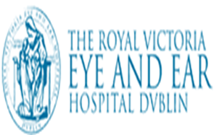 Ophthalmology Outpatient Referral Form
Patient Name: |  |  |  |  |  | Hospital: |  |  | Royal Victoria Eye & Ear Hospital
Date of Birth: |  |  |  |  |  | GP/Referrer Name:
Address: |  |  |  |  |  | GP/Referrer Address:
Tel/Contact Number:
Gender: | Female □ Male □
Referral Priority: | □ Urgent □ Semi-Urgent □ Non-Urgent High clinical/social needs □ Yes □ No  Interpreter required □ Yes □ No If Yes, First language:
Reason for referral
Vision Affected: | Yes □ No □ |  |  | Onset:
Affected Eye(s): |  |  |  | Symptom Duration: |  |  |  |  |  |  |  |  | days/weeks/months
Best Corrected Visual Acuity: | Right Eye: |  |  |  |  |  |  | Left Eye:
Additional Relevant Information:
General History: | Previous Hospital Attendance:
 | History of Presenting Complaints:
 | History of Past Illness:
 | History of Surgical Procedures:
 | Allergies/Adverse Medication Events:
 | Relevant Family History:
Clinical Exam:
Investigations:
Next of Kin: (name, contact no.& relationship)
Current Medication:

